|  |  |
| --- | --- |
| Smart Home | C:\Users\511517\AppData\Local\Microsoft\Windows\INetCache\Content.Word\smartHome.jpg |

Project Name: Smart Home

Project Control #: 1

Contents

Document Template Final Sign-Off Section 2

1 Preface 4

1.1 Intended Audience & Scope 4

2 Introduction 5

2.1 Objective & Scope 5

2.2 In Scope 5

2.3 Prerequisites 5

3 Implementation Steps 6

3.1 Code Checkout 6

3.2 Backup existing files 6

3.3 Build OIM Jars using maven build 6

3.4 Deploying Jars and Plugins 7

3.5 Lookup 7

**3.5.1** **Lookup.NonHRFeed.Configuration.Trusted** 7

3.6 CFrame Integration 11

**3.6.1** Generate the keypair files 11

**3.6.2** Import keypair files 12

**3.6.3** Import Taleo public key 12

3.7 Restart Servers 13

4 Rollback 14

4.1 Scheduler Java Task 14

4.2 Lookup 14

5 Configuration For Field Mapping to OIM: 15

6 Field Glass Schedular Import: 18

6.1 Creating FieldGlass Scheduler 20

# Preface

## Intended Audience & Scope

The purpose of this document is to present the deployment steps necessary to implement the process the Smart Home. This document is intended for the training to the team for deployment.

# Introduction

This implementation guide gives step by step instructions to deploy Smart Home

## Objective & Scope

## In Scope

The Initial setup of Smart Home application has major components, as listed below:

1. Manage Room
2. Manage House Holds
3. Manage Port
4. Manage User
5. Manage Scheduler

## Prerequisites

The following must be performed prior to executing the steps in this document:

1. Smart Home should run in the Device.
2. Scheduler services must be up and running fine.

# Manage Room

## Create Room

1. Click the Menu Admin > manage Room

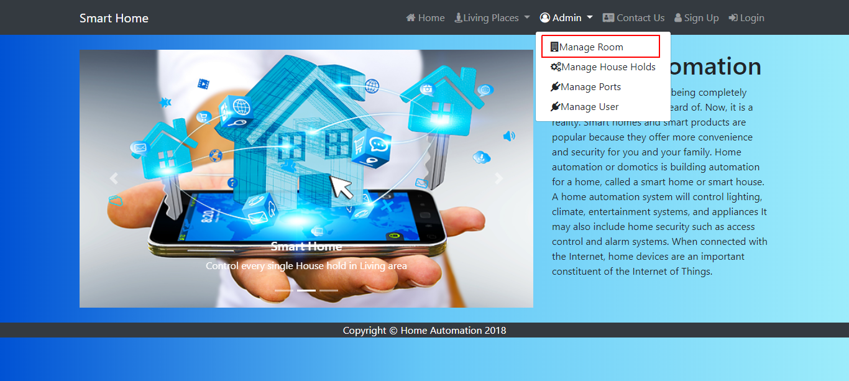

1. Click the Create Room Button 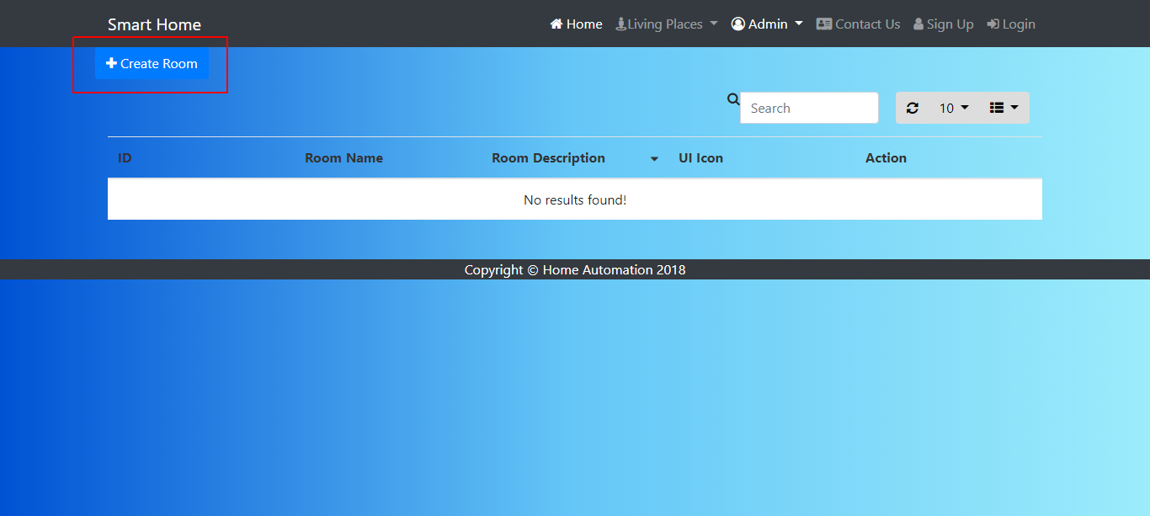
2. Add the Room name, Room description and UI Icon and click save button

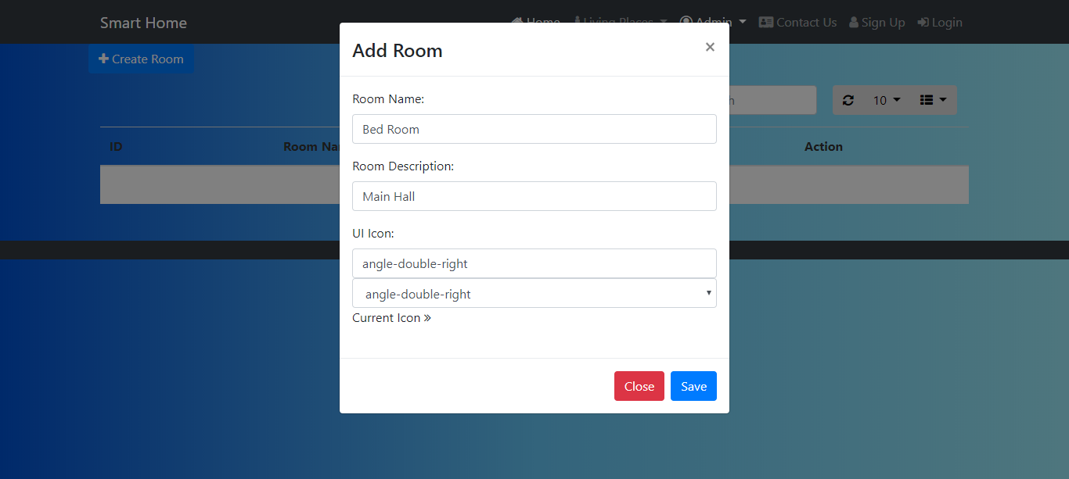

## Delete Room

1. Delete the Record by clicking on delete icon as shown in screen shot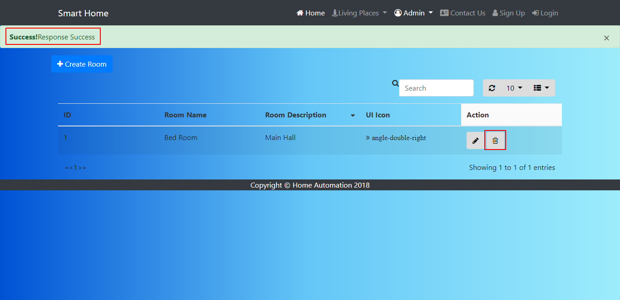
2. Click ok on confirm the alert

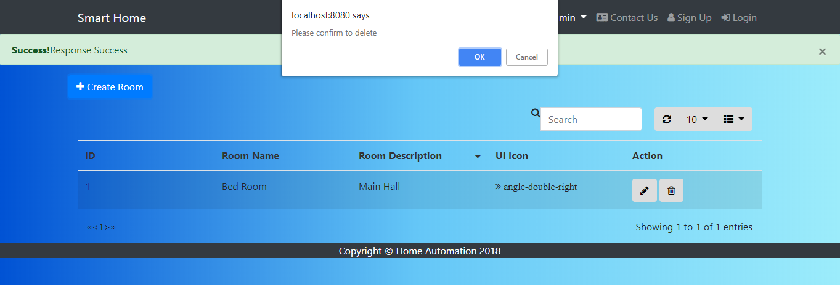

# Manage House Holds

## Create House Holds

1. Click the Menu Admin > manage House Holds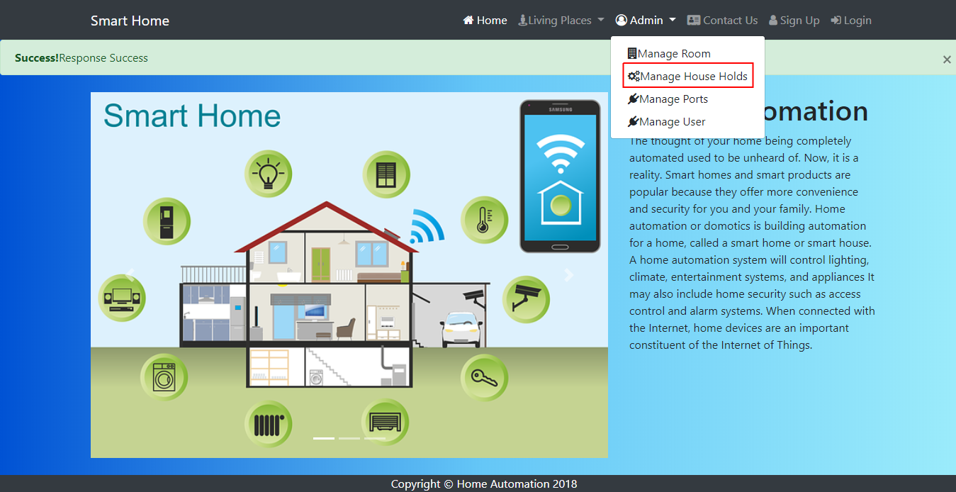
2. Click the Create House Holds Button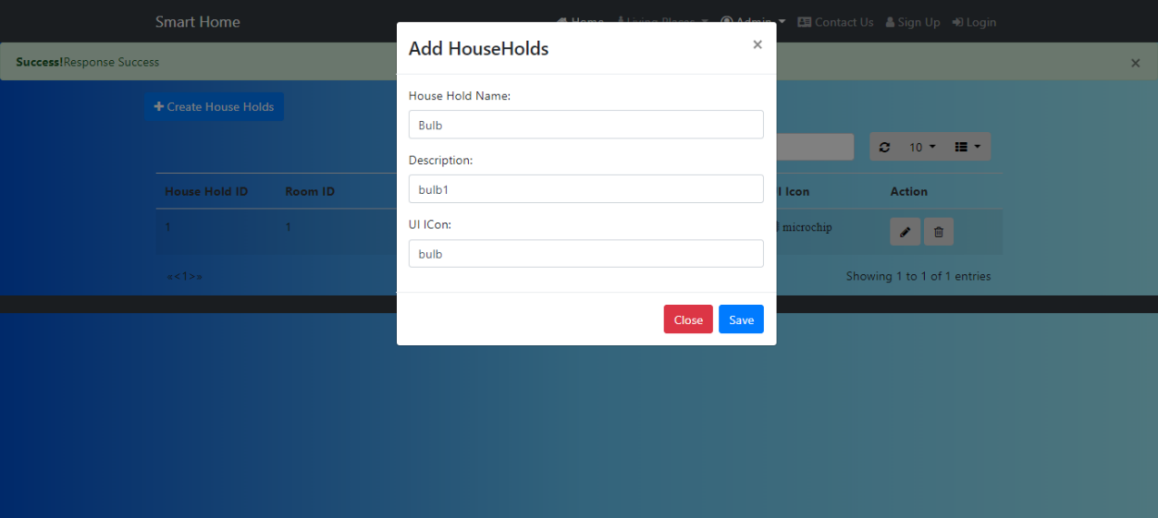
3. Add the required fields and click save button

## Delete House Holds

* 1. Delete the Record by clicking on delete icon as shown in screen shot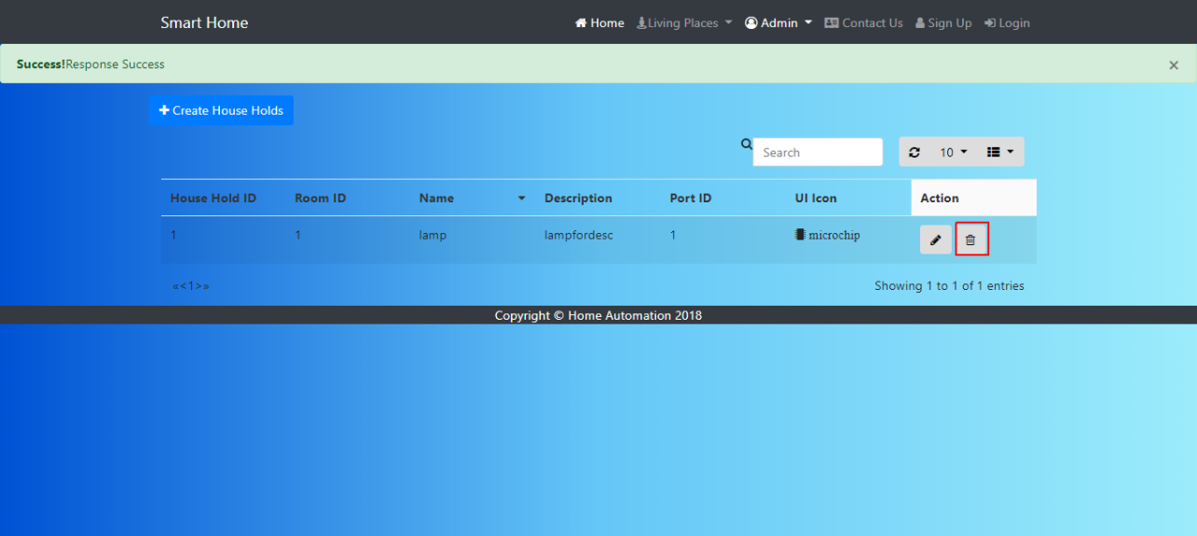

1. Click ok on confirm the alert

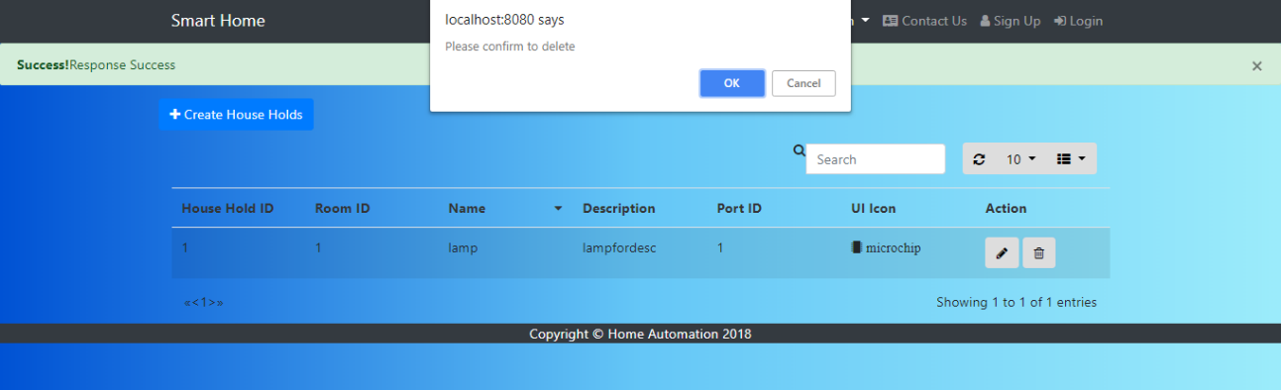

# Manage Port:

## Create Port

* + - 1. Click the Menu Admin > manage Ports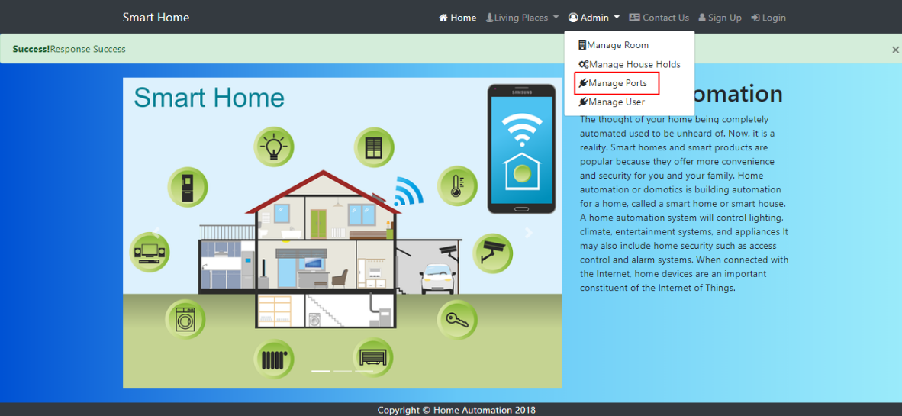
      2. Click the Create Port Button 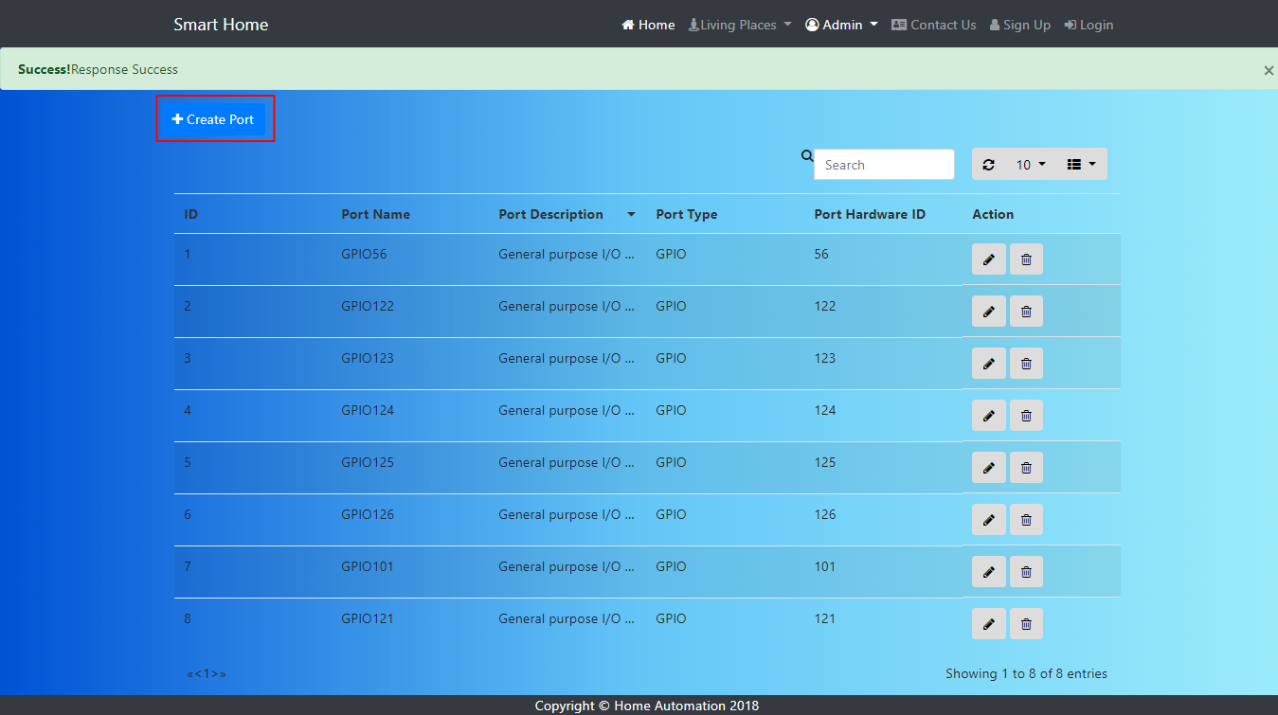
      3. Add the required fields and click save button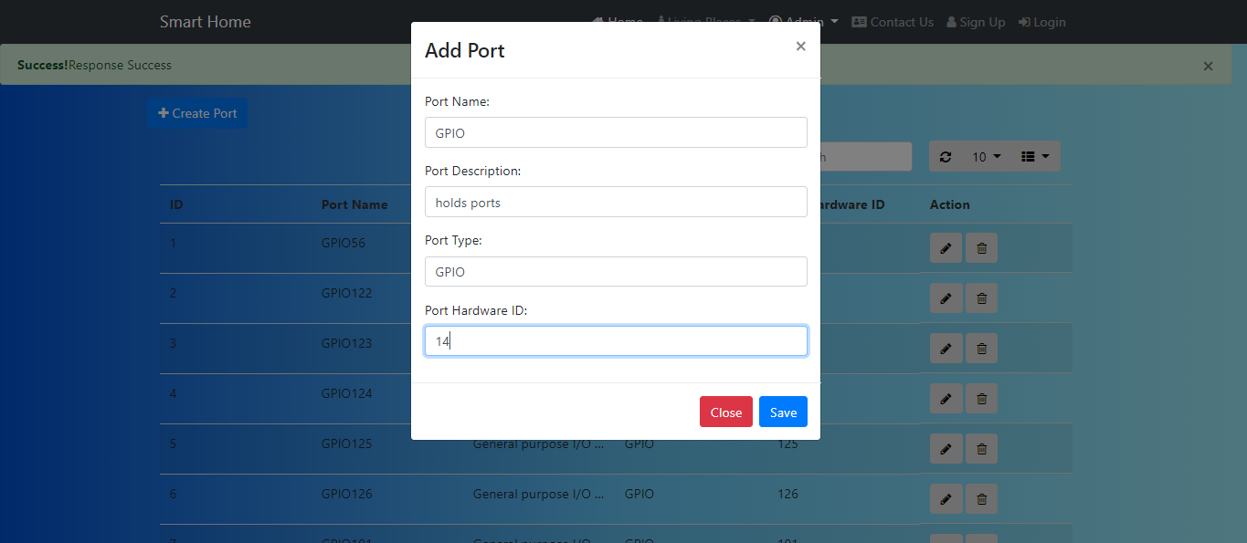

## Delete Port

1. Delete the Record by clicking on delete icon as shown in screen shot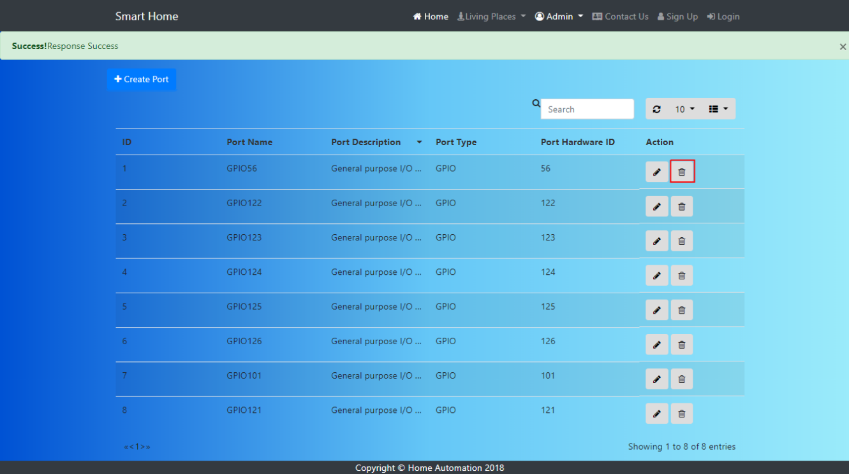
2. Click ok on confirm the alert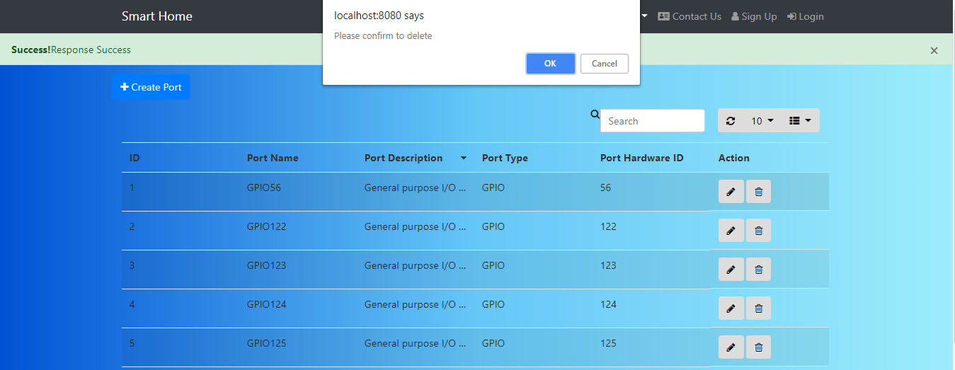

# Manage User:

## Create user

1. Click the Menu Admin > manage User 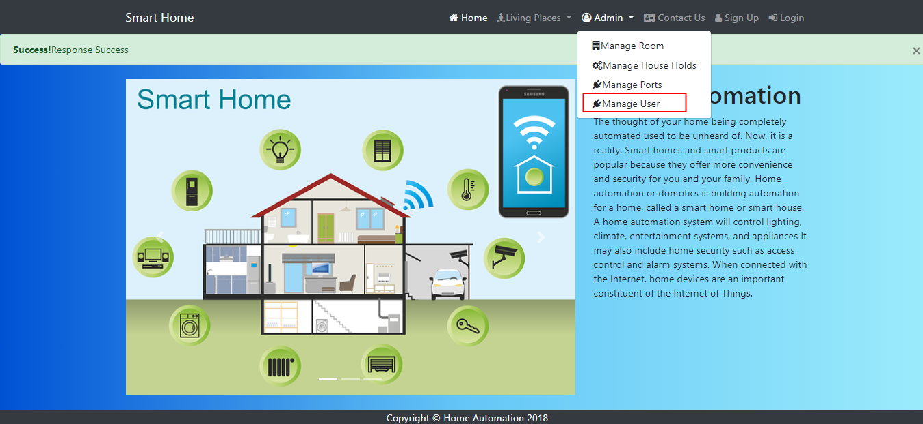
2. Click the Create User Button 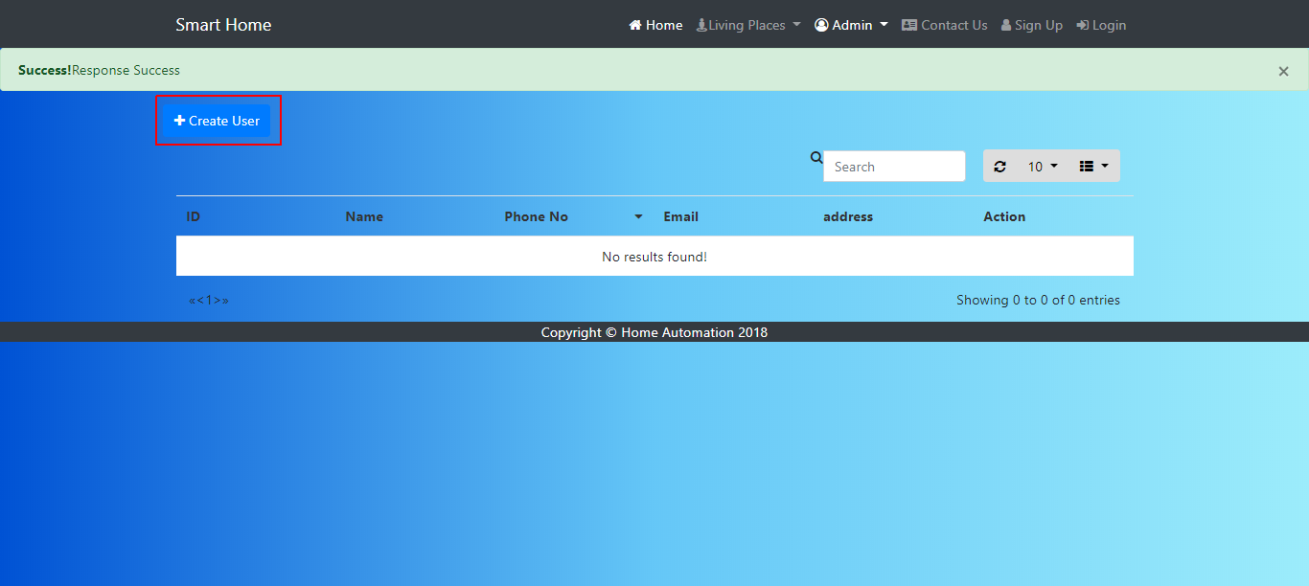
3. Add the required fields and click save button 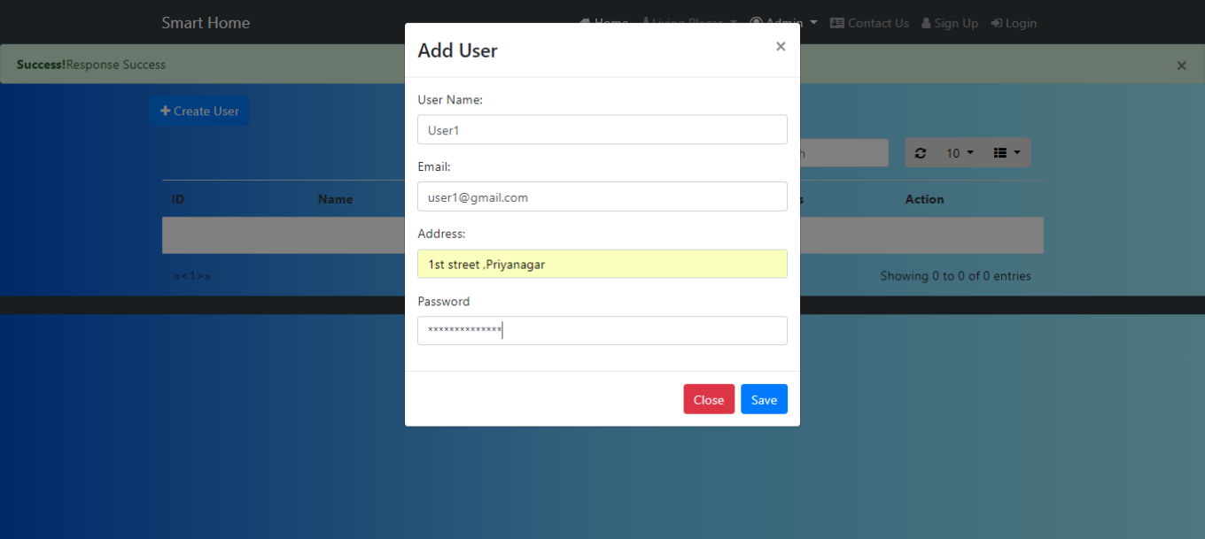

## Delete user

1. Delete the Record by clicking on delete icon as shown in screen shot 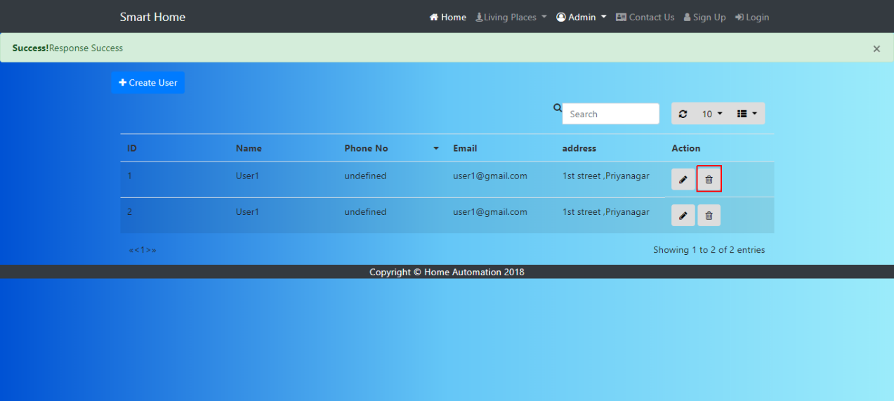
2. Click ok on confirm the alert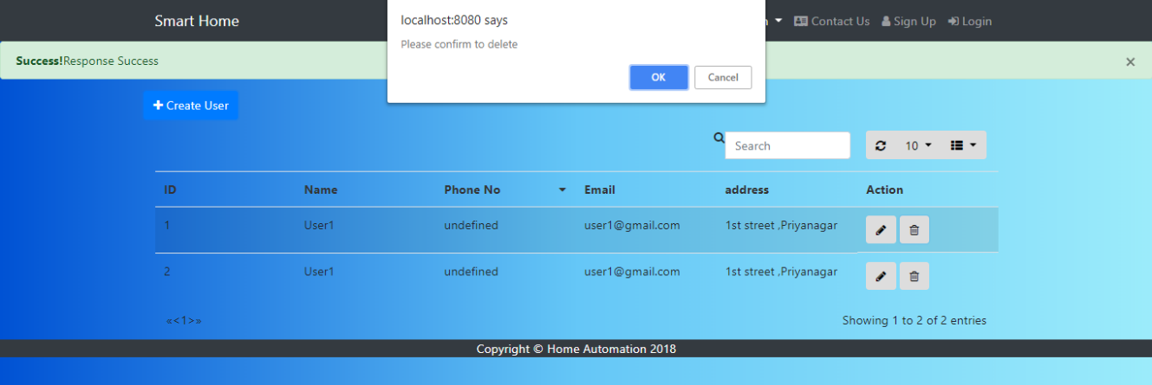

# Manage Scheduler:

## Create Scheduler

1. Click the Menu Admin > manage Scheduler
2. Click the Create Scheduler Button
3. Add the required fields and click save button

## Delete Scheduler

1. Delete the Record by clicking on delete icon as shown in screen shot
2. Click ok on confirm the alert